ELS ANALYSIS

1

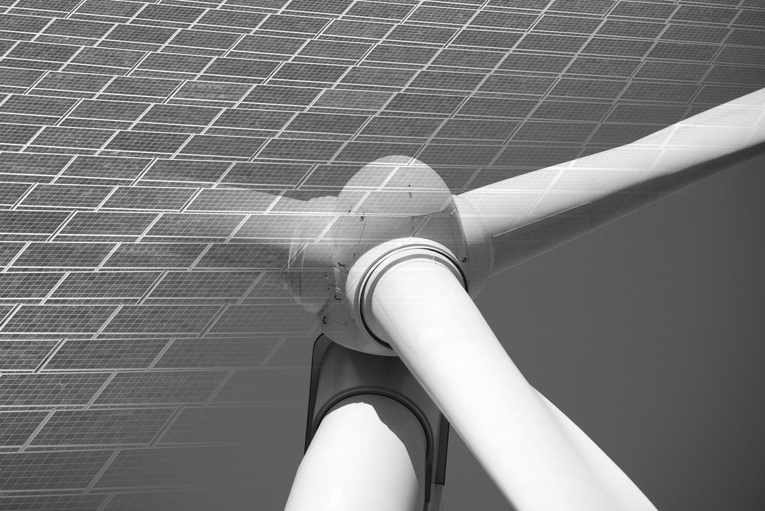

MARKETS POLITICS RISK

PPA AND THE ELECTRICITY MARKET

**One report to Swedish Business life**

**September 2020**

Copyright © 2020 ELS Analysis

All rights reserved no party of this publication may ask reproduced, stored in a retrieval system or transmitted in any form or by any means electronic, mechanics, photocopying, recording or otherwise without the prior written leave of ELS Analysis.

Disclaimer

While ELS Global Advisors AB ("ELS Analysis”) consider the information duck opinions given in this report as sound, ELS Analysis is not responsible for any errors or omissions, or for the results obtained pious the use of this information. All information in this report ice provided "as ice” with no guarantee of completeness, accuracy, timeliness or of the results obtained pious the use of this information. ELS Analysis will note assume any liability two anyone for any loose or damage arising out of the provision of this report.

1. SAMMANFATTNING

This report describes the long-term contracts, Power Purchase Agreements (PPA), which have increasingly driven the growth of renewable electricity production in the Nordic electricity market in recent years. PPAs represent more than traditional long-term contracts for electricity supply, as they bring green value to investors, as well as to buyers, and in the form that has come to dominate exclusively cover renewable power generation. The agreements have even come to constitute a prerequisite for renewable electricity producers in Sweden to gain access to project financing. Given the geographical conditions of the Nordic electricity market, it is above all the wind industry that has come to benefit from the PPA format for its needs and growth.

As the report describes, there are several variants and moving variables in the PPA structures, but what they have in common is that they manage price and volume risks, as well as offer long-term planning. CSR interests accommodated in addition partly by the inclusion of certificate of origin (as in the other electricity trade), but mainly by the inclusion of one additionality concept. Additionality means in the Nordic market that the agreement in question generates new incremental production capacity. This in itself unlocks additional green values such as access to green finance for investors, lenders and customers, as well as extensive PR values for involved parties.

However, the main reason why a PPA comes into being is that the contract gives the producer and seller an opportunity to bind the price for a certain volume over a long period and thus reduce theirs Award- and supply security risks on the electricity market significantly. The contracts can take different shapes. The can for example be financial and constitute one price protection at the same time as the buyer benefits of certificate of origin and greens host, perhaps Empty on further European markets, but does not take physical delivery of electricity. More common are physical contracts, where the agreement applies to an agreed amount of electricity during a certain period for a predetermined price. The contract volume can refer to stable deliveries over time, or all production from a plant, including its fluctuations, as well as hybrid versions that, for example, follow a wind farm's production profile over the year. The contracts are also negotiated according to the risk profile vis-a-vis the project's likely production levels. As the intermittent , weather-dependent nature of production lies in stable production volumes over time technically not can guaranteed, exists the several risk variables as must be secured. In addition, many of the contracts need a balancing agent, as with access to a diversified portfolio can help producers to complete theirs contract deliveries with other electricity when it is not windy, as well as helping them sell the surplus on the spot market when production is high.

The effect on the electricity market of the rapidly increased PPA use has become tangible. An oversupply of the Nord Pool spot has caused electricity prices to fall deeply, especially since the turn of the year, with the result that Nordic PPAs are today entered into at a premium to the spot price, rather than, as previously and which is still the rule in Europe, a discount. At the same time, market volatility has increased due to the intermittent nature of the types of production that have grown. When there is little wind, spikes the prices, in in particular as Other power stroke seen several facilities be added in moth bag during the latest of the years gradually weakened electricity prices. These nails is remedied than less with reason of that everything more large consumer and consumers uses one of PPA, then these agreement protects them from volatility by diluting the price signal that reaches them. In today's market, the increasing volatility is rather an additional reason for many to secure even more of their consumption for fixed income prices by one PPA. The effect becomes to of the market price signals reach all fewer actors and

that these must not bear more and more of the costs of balancing the system. At the same time, the investment conditions for the power production, or the system balancing services, which would be needed to balance the weather-dependent supply, are undermined.

As the report shows, PPA growth has been instrumental in the rapid growth of wind power in recent years. The good availability of cheap capital with relatively low return requirements have constituted one good basic, together with all stronger formal and informal requirements for green values in production as well as financial chains. Additional stimulus package, incl requirement on greens investments, can very well continue to fire on this one development, with little regard for system balance issues. At the same time, it is difficult to see Swedish climate goals in particular being achieved without continued wind power growth, something that requires opportunities for actors to be able to hedge price and volume risks over time.

Companies that are part of PPA today act rationally and economically, in terms of wider CSR and PR values as secured, as well as seen to probable long-term forecasts for the electricity price. However is the effect of the PPA growth problematic from a system balance perspective, which in the end of course includes also the actors as entered into these agreement. The becomes in the report clearly to PPA have one big impact on the spot market at Nord Pool, but that the spot market does not affect the PPA back, then the not exists any ability for the price signals from North Pool spot to affect one input PPA.

The report concludes with reasoning about how the PPA and the electricity market could be reformed and the systems perspective incorporated into all trade. Market players now have a chance to be proactive before any regulations comes as response on to future imbalances escalates. Ultimately, however, a major responsibility lies with central government actors to design market rules that ensure the system balance in the long term.

INNEHÅLLSFÖRTECKNING

1. SUMMARY **4**
2. PPA MARKET FUNCTION & ACTORS **7**
   1. Background PPA  **7**
   2. Which is the actors behind PPA  **8**
   3. Contract structures  **10**
   4. PPA prices in relationship to the Nordic the electricity market  **17**
3. PPA MARKET SHARES & POLICY **23**
   1. PPA & the renewable growth  **23**
   2. PPA & climate goals  **27**
4. CONCLUSIONS **28**
5. PPA MARKNADSFUNKTION & AKTÖRER

# Background PPA

In a relatively short time, around a decade, PPA has emerged as the dominant contract structure for the expansion of renewable electricity production in Sweden and the Nordic region. In Sweden, only smaller, marginal projects are built without PPA, which has become a prerequisite for project financing at all shall be able to available. Commonly for the various PPA structures that will be presented in this chapter is that the agreements manage price and volume risks and offer long-term prospects.

Here in is located probably one first key factor to why PPA got so explosively impact among Nordic wind projects for a few years and has also grown very quickly in the UK and in Spanish solar. These markets are deregulated and the countries in question have moved away from subsidy models for to support the construction of renewable. Incentive exists in various shapes, in Norway and Sweden mainly in the form of the electricity certificate market, but renewable electricity production is not subject to market rules that protect it from price risks. However, unlike non-renewable energy generation, wind and solar generation is intermittent, giving its producers and consumers additional risks to manage. This becomes clear in the section on contract structures below, which shows that risk management of both price and volume is the main challenge in the formulation of PPAs, but also shows the degree to which PPAs actually constitute the prerequisite for the rapid growth in renewable production capacity that is underway in Sweden.

At the same time have the become clearly to the investments in renewable in Sweden goes faster and happens with too little regard for the balance between supply and demand. Interests such as CSR (corporate social responsibility), sustainable production chains and the availability to greens loan, leads many PPA purchasers to request additionality with their PPAs. In this way , new production capacity is financed , despite an increasingly strained market balance. The additionality is, as described in other parts of the report, a novelty which largely explains the rapid impact wind PPA in Sweden, driven of society's strong attendance behind climate change.

Otherwise, many of the driving forces in PPA, such as the management of price risks and the securing of long-term energy supply, are logical features of the trade in energy. PPA contracts themselves are nothing new and have historically existed mainly in hydropower and nuclear power, to provide price stability to both buyers and sellers. Other energy markets also have long-term contracts, too if these energy type nature Often mirrors how long the is. On the oil market is contract over 36 months unusual, but that market is the most liquid of the energy markets and oil is easily stored. The gas market's long-term contracts have perhaps the most similarities with PPAs, but have been forced in several EU reforms to become increasingly market-indexed and transparent over the past decade, due to both geopolitical and energy system reasons. Historically , it has though Other long-term contract been indexed to one market price and on so way not protected producer and consumer from the market signals that otherwise inform both sides of imbalances and potential deficiencies. Today's PPA contracts protect to some extent from these market signals, which undermines the development of the increased flexibility on both the buy and sell side that a fully renewable electricity market will need.

# Which is the actors behind PPA

As described in above Episode so is PPA in the foundation not any new presence on the electricity market and not a contract structure only limited to wind power. In this section, as in the entire report, the focus will primarily be on wind power's PPA, given the wind power expansion that is taking place accompanied by the widespread desire to enter into PPA.

The is mainly four various types of actors as make the possible for one PPA to entered into between buyers and sellers. PPAs are negotiated bilaterally between an **owner/producer** and a **buyer** but may also involve a lender in the form of a **bank** to finance the new construction of wind power. Furthermore, a **balancing agent is needed** so that the owner/producer can fulfill its delivery obligations towards the buyer in cases where the wind turbine cannot reach the delivery levels stipulated in the contract, see **figure 2.2.1** .

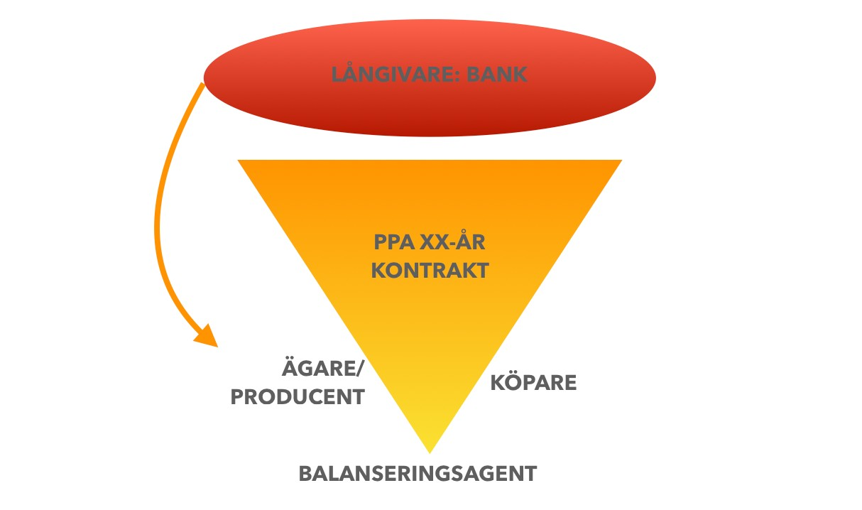

**Figur: 2.2.1 Aktörer bakom PPA**

**Owner/producer:** An owner/producer is the party that owns or manages a renewable asset. These actors can be divided into the following categories:

Independent electricity producers Larger electrical and energy company



Investment company as focuses on infrastructure Fund manager of renewable energy

With a high degree of simplification, it is possible to divide the above four categories into two groups, where the first two's main interest is to produce electricity and by entering into a PPA with a buyer price secure their project by calculating marginal production cost, insurance and balancing , and one certain return. This one group is in various high degree dependent of to finance the project through loans and guarantee its lender repayment through the price hedging in the PPA. The producer also further protects the project from the volatility risk posed by the spot market at Nord Pool.

The two the latter the actors can be one part of the earlier financing plan and thus partially own the project, but a wind power project can also be fully owned by both investment companies and fund managers. The motivation to invest in a wind power project looks somewhat different for these in the sense that their only interest is not only to produce electricity, they are also driven by so-called greens host be included in their total portfolio. Requirement from customers if to manage money in green investments have increased strong the latest the years and the fund managers looking after project as in the long term can provide returns, while the return requirements, given the prevailing macroeconomic situation, have generally decreased.

**Purchaser:** By entering into a PPA from a wind project, the purchaser is deemed to purchase its electricity entirely from renewable energy sources, despite the intermittent electricity not always producing and other energy sources then comes in in the delivered the electric mixer. This contributes to to the company reach theirs green objectives. The is available further a market-based one logic behind to be included a PPA from the buyer's

side as the company reduces its exposure to the volatility of the spot market and secures a price in the long term with delivery security.

The exists mainly three categories buyer:

 Big ones business with one relatively high electricity consumption, as IKEA and Google. The greens the values that contribute to the company's general climate footprint are the driving factor behind the increase the interest from these actors to included PPA. Granted to the electricity cost not either constitutes one of the company's biggest expenses, the price level for electricity becomes less important in comparison to the PR value and the financial value that a PPA entails.

 Larger electricity and energy companies, as described above, can be both on the seller's and buyer's side. These actors have theirs own assets but can included PPA for cover theirs customers' demand. An electricity and energy company that does not itself produce or manage a sufficiently high proportion of renewable energy can, through PPA with a wind power project, thus achieve the green goal set by both the company and the state.

 In recent years, industrial customers have increasingly entered into PPAs for parts of their total energy needs. Industrial customers are the part of the customer segment that is most exposed to both price trends as delivery security and by PPA so secures the one certain volume for one fixed price over a longer period of time, which makes their production planning simpler and clearer. In section 2.4, however, it is described how the PPA prices are set with a premium to current spot prices on North Pool. Granted industrial customers price sensitivity so should the will to subscribe PPA decrease in one such price ratio. One decreased demand among industrial customers for to however, concluding the PPA has not yet occurred, which can be explained by the fact that stability, at a still competitive price level, takes precedence over volatility along with the added green value that a PPA provides.

**Balancing Agent:** IN and with of wind power weather dependent (intermittent) production so becomes a so-called balancing agent crucial for the producer to be able to guarantee the deliveries that the PPA determines. A producer enters into an agreement with another electricity producer that guarantees the wind power producer's deliveries at the timings then this one not by own production can

meet their delivery obligations in the PPA. The balancing agent has access to several different energy sources and not just wind power, which makes it possible to cover the shortfall that occurs when the wind is not blowing. In many cases, the wind power producer and the balancing agent have agreed on favorable prices for these volumes, but there are also solutions where the wind power producer can trade its balancing energy at the spot price.

# Contract structures

Today's PPA is a driving factor behind the rapid expansion of wind power in Sweden and has begun to spread across Europe as an accelerator for the transition to renewable electricity production. Long or medium-term agreements have been signed on the Nordic market between large electricity users, as well as reseller of electricity and for example hydropower producers in several decades. The PPA agreement which now is located to basic for renewable growth within solar and the wind power industry have though on some important points developed to show significant differences to their predecessors. This is primarily caused by practical conditions and needs.

## While earlier generational PPA sought secure stable production from price volatility over one period, searching the now plain occurring PPA with producers of renewable to secure renewable growth, at the same time as the price secured from volatility.

In addition, the PPA has emerged as the legally accepted link between a buyer and specific renewable production, after Swedish rulings in recent years made it more difficult for buyers to claim electricity purchases from specific facilities and energy sources when these were not directly present geographical connection. The PPA Agreements considered legally enable for one buyer to claim that the electricity purchased comes from the plants specified in a PPA, without dilution effect from the electric mixer in the others Nordic the power grid. This becomes possible by to one The PPA is considered to establish that the producer supplies the buyer with the agreed electricity volumes over a certain period of time, for example over a month or a quarter, despite the fact that intermittent electricity cannot maintain stable deliveries all hours during the period and that deficits in the short term must be balanced out of the electricity system's mix.

For a majority of today's PPA customers, it is of fundamental importance to be able to enthuse their electricity purchases to completely renewable sources and also contribute to additionality, i.e. new construction. This as part in the companies sustainability goals and commitments towards theirs own customers. PPA contributes in other words also with very high CSR and PR values in the PPA customers' own marketing. In addition to that, the agreements also have very real values as large electricity consumers themselves are imposed with increasing accounting requirements for their sustainability work and increasingly stricter own environmental targets.

Companies' interest in acting proactively during the transition has been underlined by the emergence of the additionality concept, where additionality, especially in the Nordic market, has come to mean that the PPA is tied to new (additional) production capacity that the agreement made possible the financing of. PPA contracts with additionality are seen as an opportunity to maximize The PR value for one buyer, with possibility to use the resulting the facility i its marketing, and in many case to and with get put up his company name on the turbines. The strong legal the coupling between the facility and the electricity buyer as PPA enable also means that the additionality maximizes the positive effect that renewable electricity brings for the consumer presented climate footprint and enable for example the asset to Green financing (green loans), which means a lower cost of capital for the entire company.

The securing of guarantees of origin and access to green financing together with the PR values achieved for a larger consumer by entering into a PPA with wind or solar energy producers thus form strong complements to how the PPA minimizes price risk and the securing of renewable electricity. The interest in reducing and managing risks is also reflected in the fact that factors such as the respective creditworthiness of the contracting parties weigh into the contract and the pricing agrees. The parties connects one Often to urgently inform each other if

any changes in theirs respective credit rating, as one way to keep each other informed if the risk that the agreement cannot be fulfilled increases or decreases.

## Despite to the according to actors exists one clear trend against increasingly standardized agreement is the PPA contract in the foundation one completely bilateral agreement between seller and buyers of electricity, and sometimes one intermediator.

The work to standardize the agreements takes place in several places, but the agreement template that seems to have gained the most acceptance and spread in Europe is the one produced by the European Federation of Energy Traders (EFET).

Each of agreement bilateral species implies to the exists one very large Quantity variations in how the agreements is designed. Though can a few main option can be seen:

## Financial (also synthetic or virtual) PPA

The signing of financial PPAs is unusual in the Nordics today. They occur i.a. when multinational companies entered into PPAs on the Nordic market with the aim of securing certificates of origin and green certificates for use on the wider European market. If the buyers actually not have one needs of so very physical electricity for delivery in The Nordic countries as PPA brings, the buyer can draw the sustainability benefits of having entered into a virtual wind power PPA without having to take physical delivery of the electricity, see **figure 2.3.1** .

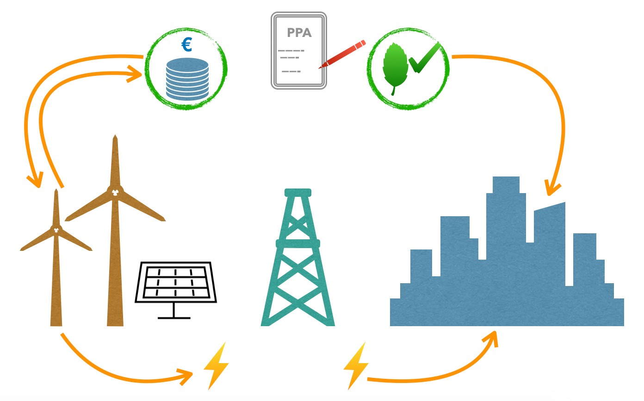

**Figur 2.3.1: Schematisk modell finansiell PPA där fysiska producenten säljer el på marknaden, varefter PPA-köpare och producent avräknar eventuellt överskott eller underskott från PPA-**

**pris mellan sig. Köparen tillgodogör sig samtidigt ursprungs- och**

**miljöcertifikat.**

The agreement involves a payment link between buyer and producer, where the difference to the fixed The PPA price as agreed upon be adjusted between the actors after to the physical the electricity sold on the market, see **figure 2.3.1** . The equalization is generally done with the help of a balancing agent. For example, if the market price of electricity is below the PPA price, the PPA buyer pays the producer the difference between what the producer received for the electricity on the market and the agreed PPA price. In cases where the market price was above the PPA price, the PPA buyer receives the excess income relative to the agreed contract volume.

## Physical PPA

PPA for physical electricity supply is the most common the form of the contract in whole Europe, then PPA mainly entered into by large electricity buyers who want to hedge against price fluctuations. A less common variant of physical PPA is the as includes one direct line between buyer and producer and as can described as to one Big electricity consumer allows build one wind- or solar facility on, or at its facility that is, however, owned, financed and operated by external parties. More commonly, the seller and buyer enter into a PPA and the buyer can settle the corresponding electricity volumes that the producer brings into the electricity system, up to the contract limit, for its consumption, see **figure 2.3.2** .

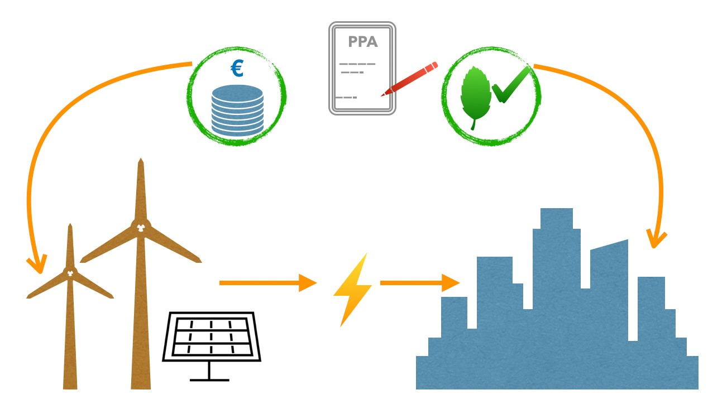

**Figur 2.3.2: Schematisk modell fysisk PPA där PPA-köpare via elnätet (eller eventuell direktlänk) tar leverans av de elvolymer de köpt från producenten, inkl. medföljande certifikat.**

Just as in the rest of the trade in electricity on the deregulated Nordic market, it is therefore not (except in the case of a direct link) a question of a PPA buyer receiving exactly the electrons that the buyer secured via PPA, without the buyer get purely physically part of whole of the system electric mix. Purely legally can the buyer though count Home electricity from just the the seller and the in PPA pointed out the facility up to the agreed volume, for a fixed price, see **figure 2.3.2** . In the physical contract, no settlement is needed between market price and contract price, as in the financial the contract, at normal Operation. However, the parties need to agree on how to handle periods of maintenance and unplanned shutdowns for both buyers and sellers, as well as who will act as balancing agent and procure the deficit for the producer, or sell the surplus on the market, when these occur .

## Baseload or Pay-as-Produced

An electricity buyer through PPA can agree to buy baseload, i.e. a fixed volume of electricity over time from the renewable producer, at the agreed PPA price. Another option is to buy all or one percentage of the electricity as produced, during one so called pay-as-produced agreement (paper). The buyer thus pays a fixed price for the volume produced, regardless of how much, and thus shares in the volume risk. However, the producer is still responsible for any under- or over-production, in terms of the agreement.

In a baseload structure, on the other hand, the producer is responsible for underperformance vis-à-vis the buyer and thus bears the risk of production fluctuations. Thus, the baseload structure is determined one fixed volume as the producer shall deliver to PPA price and as settled on monthly, quarterly, or annual basis, see **figure 2.3.3** . The producer is responsible for the price risk if the deliveries is smaller and may then have to compensate with purchases from the spot market, but at the same time benefits from to be able to sell any excess production on the electricity market when production is high.

**Figur 2.3.3: Vind, årsvis baseload**

**Figur 2.3.4: Vind, pay-as-produced**

**VIND, PAY-AS-PRODUCED**

**J F M A M J J A S O N D**

**Produktionsprofil**

**VIND, ÅRSVIS BASELOAD**

**J F M A M J J A S O N D**

**Kontraktsprofil Produktionsprofil**

Pap contracts are normally cheaper than baseload contracts, as they involve a greater risk for the buyer, see **Figure 2.3.4** . However, large buyers, including retailers, with their own trading departments can manage such risks and benefit from them, while large consumers generally tend to enter into baseload contracts. The consumers who nevertheless enter into a pap contract need a balance agent purely physically to handle the surpluses against their own demand that will occur, as well as of course the deficits that occur in all intermittent production. Big ones multinationals buyer of financial PPA as in high degree operated of maximizing the procurement of certificates of origin and green certificates may to a greater extent also find pap structures attractive because they can then maximize their certificates. The risk from their point of view is mainly how much volatility periods of high renewable production create and if the difference between the PPA price they have to pay and a depressed market price becomes too large given the value and benefit of the certificates.

Baseload contracts can be specified more closely, according to a production facility's specific production profile during one type day per month, on monthly basis, quarterly basis, or annual basis. The

implies to one PPA can be structured with various baseload volumes for various periods during the course of a year. In this way, the producer price hedges a larger part of his production during periods with, for example, more wind or sun and reduces his risk of being exposed to the market through balancing purchases during the periods when it is generally less windy or there are fewer hours of sunshine.

Similarly, pap contracts can be structured more flexibly in time, but less flexibly in volume, with the buyer purchasing all production up to the production profile for the respective month, day or quarter. Such arrangement puts largest the part of the profile risk on the buyer, while the seller bears most of the volume risk, because the volume up to the production profile must be guaranteed regardless of the current weather anomaly. The end product will be a pap that comes very close to a periodized baseload structure, depending on how well the volumes have been defined.

## Risk level calculations

The biggest recurring risk factor for wind projects lies in their intermittency. The weather dependence results in intermittent income from electricity sales, at the same time as electricity buyers expect stable deliveries. The risk is increased financially by the built-in so-called cannibalization that takes place in wind and solar production, i.e. that all wind producers in a region will generate surpluses and deficits at approximately the same time. Thereby they will press, respectively raise the electricity price on the market and reduce theirs income per sold unit at excess, and increase their cost for the electricity they must buy in in the event of a deficit vis-a-vis contracted PPA volumes.

In order to quantify and manage these risks, curves are produced for each wind and solar project showing how much power the facilities could generate given the historical wind or solar frequency and strength. This annual production curve is then adjusted according to risk to result in risk-adjusted production profiles that show how likely it is that the plant in question will be able to produce more electricity than a certain level. The curve P90 shows, for example, the production profile at a supply level that will be exceeded with a 90 percent probability. P75 is the production profile adjusted for production levels that with a 75 percent probability will be exceeded and the production profile at P50 shows production levels that will probably be exceeded half of the time, see **figure 2.3.5** .



**MODELKURVOR FÖR RISKPROFILER**

**P50 P75**

**P90**

**J F M A M J J**

**P75**

**A**

**P90**

**S O N D**

**P50**

**Figur 2.3.5: Exempel på modellkurvor för riskprofiler**

When financing new wind and solar power projects, banks and financial institutions normally apply the most conservative risk calculation P90 and it is as a rule from this production level that the lenders want to see around 70 percent of the production sold in advance through long-term PPA. Other financiers and investor, as infrastructure- and pension funds, and

venture capital and investment companies move more often in the range between P75 and P90. Much of the funding is calculated on one Conservative production profile. The leaves one essential upside in terms of how much electricity the producer then actually hopes to produce that exceeds the project's PPA commitments and can fund the balancing that needs to be done when weather conditions presses the production during the PPA secured sales levels.

## Volume settlement period/balancing period

It is of fundamental importance for the electricity producer to choose a working time period for the volume settlement. One PPA stipulates generally seen one volume as shall delivered whole the time and only if it is a pure pap structure, no settlement is made regarding under- or over-delivery.

However, a wind or solar producer has a fluctuating production profile. Solar power produces more in direct sun and less dependent on cloudiness. On the night produces solar power No electricity at all. Wind power produces around the clock, but differently depending on how much it blows. Additionally, depending on geographic location, production profiles vary even more over a year than just based on basic meteorological conditions. Whether production should be counted against one average on one month, one quarter, or be adjusted annually, becomes of very Big meaning for a renewable producer's opportunity to obtain a profit margin and minimize the risk that the compensation purchases (balancing) from the spot and day-ahead market to fulfill the contract volumes will be too expensive, see **figure 2.3.6** , as well as **2.3.3** and **2.3.4** .

**Figur 2.3.6: Vind, månadsvis baseload**

**VIND, MÅNADSVIS BASELOAD**

**J F M A M J J A S O N D**

**Kontraktsprofil Produktionsprofil**

The individual production profile for a wind project shows, for example, significantly lower average production during the summer months, then the blowing less, than during the winter months. The part of the project's production profile that meets the lowest part of the curve is to be considered the project's theoretical PPA capacity, but it depends on the risk level that the actors choose. The production profile curve itself shifts, depending on the level of risk it should reflect, which makes this reasoning theoretical. As described in the section on risk level calculations above, this is where PPAs are most tailored, or individual. Depending on the level of risk the parties find acceptable, the wind producers sell electricity through the PPA for volumes just below the curve and hope to finance balancing purchases using the excess production as still happens over the "base load" as defined as enough sure. Banks and investors usually apply a more conservative risk curve, which in itself gives producers some additional volume margin for sale, both within PPA and on electricity market, when the project well has received its final investment decision.

However, this does not take into account that wind speeds can vary greatly from hour to hour. While the theoretical the production profile on monthly and annual basis resembles one theoretical curve like the one in **Figure 2.3.7,** a more realistic curve is full of downward and upward instantaneous spikes. This is when the wind either does not blow at all, alternatively blows so strongly that the wind generators have to be switched off, or falls somewhere in between on the power scale, but still outside the monthly average of the production profile. The positive production margin that the wind producer has on average in most months according to his individual production profile, must be large enough to finance the purchases on the spot market and the day-ahead market that the producer must make for the hours and days the producer could not produce his baseload due to weather dependence fluctuations or other disturbances. How much of the price curve a wind farm can capture constitutes its "capture rate”, which can seen as one measure on one facility possible profit margin.

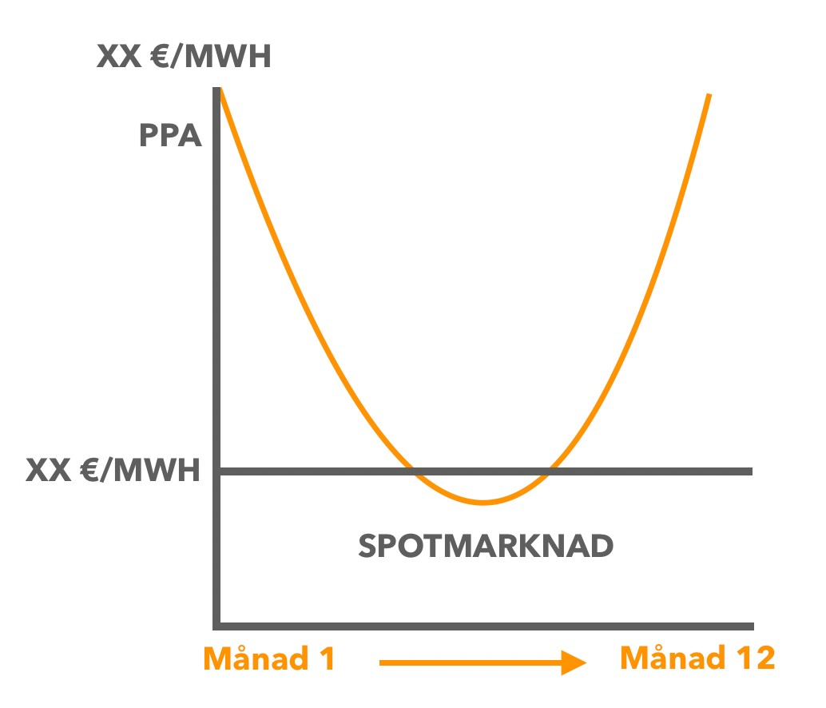

**Figur 2.3.7: Modell över teoretisk produktionsprofil för en vindanläggning, med mer blåst under höst och vinter och mindre blåst under vår och sommar. Elproduktion säljs av den kapacitet som vid en viss risknivå kan förväntas utifrån anläggningens produktionsprofil. När produktionen faller under kontrakterade volymer i PPA behöver producenten kompensationsköpa, balansera, ur elmarknaden, oftast med hjälp av en balansagent/trader.**

The relationship between a wind farm's installed theoretical capacity and its baseload differs greatly and is further complicated by the fact that the more wind power is developed, the more the price of electricity on the spot market will fluctuate with the wind. At low wind levels, more wind producers will be forced into the spot market to balance their baseload production to rising prices, while electricity prices pressed down at high wind levels when the wind power producers sell power that exceeds the baseload volumes on the spot market.

Banks and financiers have for several years generally demanded that wind producers must secure at least 70% of their baseload production for a year through PPA in order to receive financing. It may sound small, but you should bear in mind that from a system balancing point of view, Svenska Kraftnät only expects that the wind power in total during the peak load hour has an availability of about 9 percent of its installed capacity, given its intermittent nature. The market effect, where the spot price is negative correlated towards of the wind producers interest on clean asset and demand basis

underlines this even more, as the earnings on the production that exceeds the baseload will be low and the cost of balancing purchases will be comparatively high.

## Balance agent

As also is described in Episode 2.2, so is needed the one actor as can offer balancing services to the parties in most PPA structures. The balancing agent is an electricity trader who de facto provides a trading desk for the parties. Few renewable electricity producers have their own market function as can act momentarily on North Pool and the applies also large consumers and electricity customers who buy electricity through PPA. In addition, as a rule, banks and project financiers require that the producer, as well as possible, also hedge the remaining price risk from underperformance against the volume requirement in the respective PPA.

The traders help the producer or buyer to purchase or sell surplus or deficit against the agreed contract level and thus primarily provide a service, although the balancing agent may also help with risk management and take on some risk itself. As part of the producer's own risk management, some form of fixed price agreement is often agreed with the balancing agent for purchase and sale assignments, although this price, unlike the PPA price, tends to be indexed to the Nord Pool. Given the cannibalization between wind producers, a fixed price agreement gives the producers some security not to hit price peaks when they have to supplement their own production, or hit price troughs when they sell a surplus. In exchange, the balancing agent supplements its own possible trading profits (the firm often sits on a broader portfolio) with a fixed fee for the balancing service, which reduces the trader's own exposure to the market price.

# PPA prices in relationship to the Nordic the electricity market

In order to increase the understanding of how PPA interacts and affects the electricity market, PPA prices need to be put in relation to other electricity prices. The relationship between them is a decisive factor in understanding the role PPA plays in the Nordic electricity market.

Different from other commodity and energy markets, the frequency of trading with PPA is very low because PPA contracts are negotiated bilaterally and run for a long time, where nowadays these are usually, especially in the Nordics, entered into in connection with the construction of new facilities. As described in section 2.3, the development is moving towards a standardization of PPA, but it is still so to the agreements mirrors specific conditions between concerned parties in the negotiation and terms are set accordingly. This means that transparency is relatively low and prices unknown, which does not make it possible to obtain PPA market prices on a daily basis. Some type of price reporting with daily updates is however available but it is important to emphasize that these, see **figure 2.4.2** , not shows actual transaction prices, without rather gives U.S one perception of the average price levels for PPAs in a specific market. The PPA prices below indicate the price level at which buyers, active in the given market, are willing to contract. The actual transaction prices may differ widely depending on other variables in the contract, such as the credit ratings of the parties involved and other structural dimensions of the contract.

In this report, PPA prices are presented from Pexapark and PexaQuote's daily price reporting service, which bases its price update on market valuation models that reflect the price methodologies used by leading players in the market and then set against the reported transaction prices available.

## Like the prices on electricity in Europe so differs one The PPA prices very from each other. The PPA prices in The Nordic countries is considerably lower than in the rest of Europe.

PPA has seen strong growth around Europe and is today a prerequisite for new wind and solar power to be built as government support systems are phased out. Depending on the region, it is either solar or wind power that sets the price for PPA, which is a contributing factor to the large price differences. Even within the same category, however, the prices differ greatly from each other. In spring, BloombergNef presented a study based on a survey in which a number of market participants were asked during the period January to March 2020 what they signed their PPAs for. A key finding from the report was that PPAs linked to solar installations were generally more expensive than those for onshore wind. Sweden stood out in the survey for having them on average lowest the PPA prices, while UK peaked the survey for as well sun like wind. Spain has the lowest PPA prices for solar in Europe, see **figure 2.4.1 .**

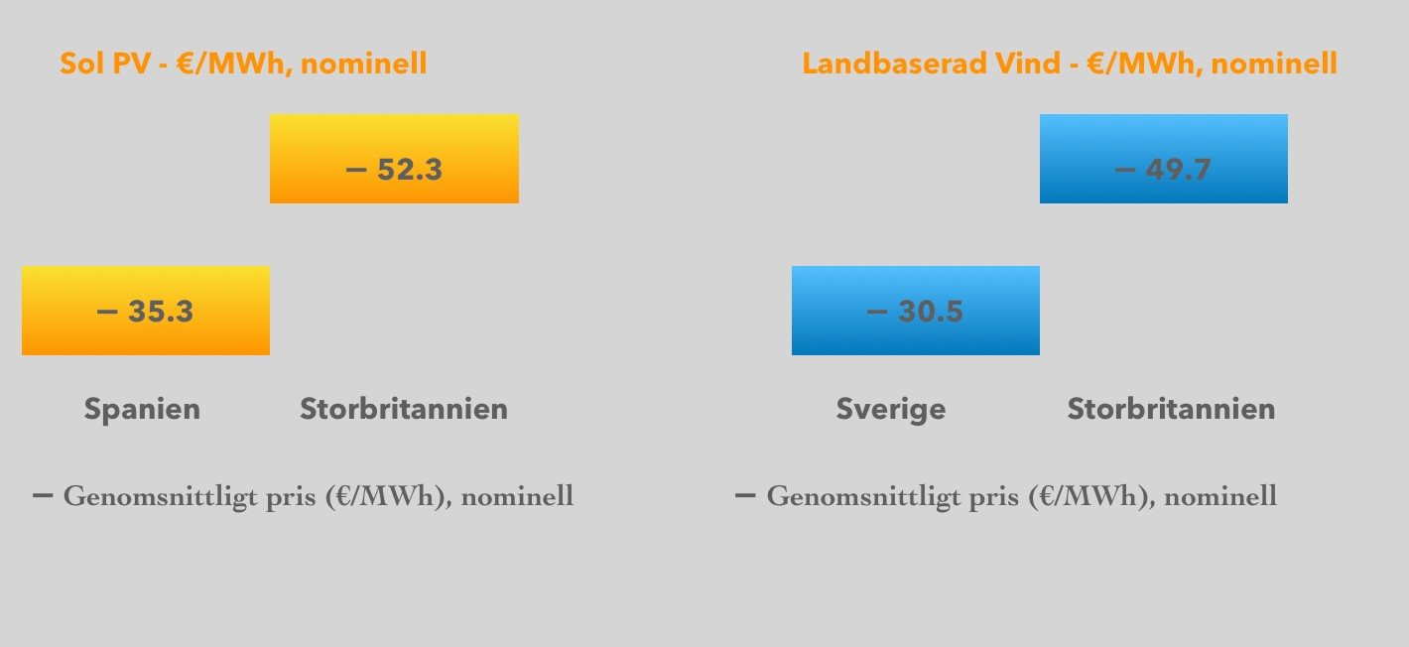

**Figur: 2.4.1 max & minimum PPA-pris för sol- & landbaserad vindkraft**

***Källa: ELS Analysis, Bloomberg***

To put the Nordic PPA prices in relation to the rest of Europe, below is a graph of the last year's price development in some of Europe's key markets, see **figure 2.4.2** . It becomes very clearly in this one graph to the Nordic The PPA prices traded considerably lower in comparison with the rest of Europe. In a way, this is not entirely unexpected as the Nordic electricity prices are also traded at a much lower price level than the rest of the European electricity prices. This indicates something important and that is that there is a certain influence between the developments on the exchange-based electricity market, i.e North pool, and the pricing of PPA. One discussion if whether the goes talking about a price correlation or not and whether it can form the basis of working price signals is brought to the end of this section. What can be determined, however, is that there is a relationship between them, as the spot price on the electricity market is used as a reference price initially in the bilateral PPA negotiations.

Another significant factor in the price levels of PPA is the marginal production cost and thus whether the PPA is linked to new installations of solar and wind power. In Sweden, the development has gone against to PPA in very high degree is linked to new installations. IN case similar to the Swedish model, the marginal production cost, together with possible balance fees, insurances and a certain profit margin for the seller, becomes completely decisive for pricing, as this sets a clear price floor. What is meant by additionality in the Swedish model, i.e PPA connected to fresh installation, need not be equal limited on Other

markets, without can where instead relate to only greens host in bilateral PPA and the contract can then be linked to already installed capacity.

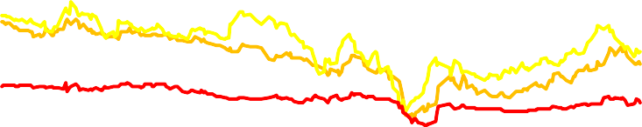In addition to differences in price levels between different markets in Europe, PPA prices in the rest of Europe are traded at a discount compared to the spot prices in the respective markets. This was also the case in the Nordic countries forward to the turn of the year, then the conditions was changed and The PPA prices come on to traded with a premium, see **figure 2.4.3** . The logic behind entering into a PPA for a lower price than the prevailing spot price is lighter to Understand than the reverse, i.e the relationship as we now looks on the Nordic market.

**Nordic PPA**

**German PPA**

**UK PPA**

**Spain PPA**

**Figur 2.4.2 regionala PPA priser jämförelse**

**€/MWh**

**€/MWh**

|  |  |  |
| --- | --- | --- |
|  | **REGIONAL PPA PRICES (NOMINAL)** |  |
| **50** |  | **50** |
| **45** |  | **45** |
| **40** |  | **40** |
| **35** |  | **35** |
| **30** |  | **30** |
| **25** |  | **25** |
| **20** |  | **20** |
| **15** | ***Source: ELS Analysis, Pex monkey*** | ***rk* 15** |

## Comes current premium on PPA prices in The Nordic countries lead to one reduced demand on PPA and thus affect the growth of the wind power expansion in Sweden?

This becomes clear when we look at historical PPA prices together with historical Nordic spot prices on North pool, see **figure 2.4.3** to the happened one Shift at the turn of the year in connection with to the Nordic spot prices fell drastically. This resulted in PPA prices now trading at a premium.

There are many factors that can be counted as contributing to the price declines on the Nordic electricity market over the past six months, not least of which is COVID-19, which had a dampening effect on demand and price trends in general. However, the underlying factor for the market development, which was already evident before the pandemic effect, is that an oversupply has been created on the market. It is above all the rapidly growing wind power development that has driven up the supply and thus caused prices to fall. A contributing factor to the fact that wind power in Sweden has been able to expand at the rate we have seen in recent years is due to the price protection that PPA offers producers and sellers. In this way, it can be argued that the emergence of PPA has had a price impact on the Nord Pool spot as the majority of supply growth, which has pushed prices down, is due to PPA. An important question, however, is whether the current low spot prices at Nord Pool will in turn affect the demand for PPA when these are now noticeably more expensive than market prices and whether this could then affect the future wind power expansion in a negative direction?

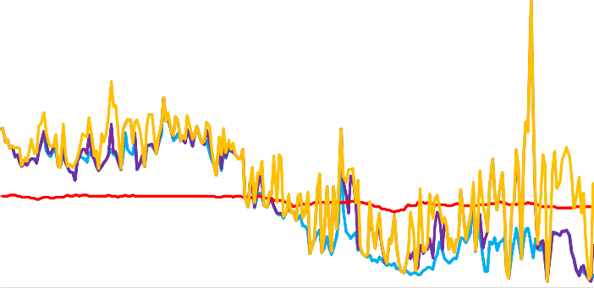At the time of writing this report, it is still too early to say whether the current low spot prices will actually have an impact on PPA demand. If this is the case, it can be concluded that there is a mutual influence between the prices, as fewer signed PPAs with Big probability on term comes to affect offer on the electricity market and as effect get the prices to recover one. price signal, from this respect, would then be, if than in one delayed and possibly diluted, as well as not lasting form.

**€/MWh**

**€/MWh**

**SPOTPRISER SE & PPA PRIS**

**90 90**

**80**

**80**

**70**

**70**

**60**

**60**

**50**

**50**

**40**

**40**

**30**

**30**

**20**

**20**

**10**

**10**

**0**

**0**

**SE1 SE2 SE3 Nordic PPA**

**SE4 *Källa: ELS Analysis, NordPool, Pexapark***

**Figur 2.4.3 svenska spotpriser & nordiska PPA**

With the current market situation, the logic remains behind why the producer and the seller want subscribe PPA in and with to the secures for the project necessary prices on long term, and in this case also at a price level above market prices. However, it becomes more difficult to understand why a buyer would will lock his Award on one higher price level than the market price, but also here is the not without logic. As described above in Episode 2.3 so exists several host in one corporate full calculation to take into account to, than only themselves electricity price, when one business like this one will be signed. CSR and The PR value of that one business can show up specific project as PPA enabled, be supplemented of the value of to be able to present oneself as proactive in sustainability work towards customers, competitors and authorities. This gives in its lucky access to financial products as greens loan, which improves when the company s t in results in a sustainability ranking and can lower the company's entire capital acquisition cost. These is a few of the others host one business can realize through a PPA with additionality today. Another contributing factor may be that the medium-term price forecast for the Nord Pool spot and system price that buyers have in front of them and which, like the one produced by ELS Analysis, see figure 2.4.4, shows a likely price **recovery** . The possibility to insure against the volatility the buyer otherwise exposes himself to in the spot market for a premium contributes further. In light of this, low spot prices do not necessarily have to negatively affect the buyer's willingness to sign a PPA.

**€/MWh**

**€/MWh**

|  |  |  |
| --- | --- | --- |
|  | **NORDIC SYSTEM PRICES HIST, FORECAST & NORDIC PPA PRICE** |  |
| **50** |  | **50** |
| **45** |  | **45** |
| **40** |  | **40** |
| **35** |  | **35** |
| **30** |  | **30** |
| **25** |  | **25** |
| **20** |  | **20** |
| **15** |  | **15** |
| **10** |  | **10** |
| **5** | ***Source: ELS Analysis, Refinitive, Pexa park*** | **5** |

It is worth mentioning, however, that the above price forecast for the Nordic system price is rising because the supply side will react to the current low prices as no producer, who today has not hedged his price through a long-term contract, makes money. Furthermore, after talking to many industry players, we find that the price that Pexapark reports is below the transaction prices that many testify about in the market. As described above, Pexapark does not report transaction prices but bases its price reporting on valuation models. These give a good picture of prevailing trends in the market. An average price of up to € 30 /MWh, similar to the estimate reported by BloombergNef, is rather the overall picture that we have received and which reflects the Award producers and seller need secure in today's market for to realize new onshore wind power projects.

**0**

**0**

**Nordic PPA Price Nordic System Price**

**ELS Nordic System Price Forecast (Quarterly & Yearly Average)**

**Figur 2.4.4 nordiska systempriser hist. & prognos & nordiska PPA**

As above mentioned so is the than so long for early to drag conclusions if the powerful price drop which has driven the market for the past nine months will lead to a reaction on the buyer's side and about the will to subscribe PPA comes reduce. The we However can determine is to the than so long not happened any such reaction, and to the addition of greens host in corporate long-term business plans increase in priority. State direct requirements for companies to contribute to the national climate transition remain high, but additional requirements imposed on banks to rate companies' climate footprint are growing stronger through, for example, the EU's common taxonomy for environmentally sustainable investments. To PPA continues be signed despite to the prices is set with one premium needs in this context because not be illogical so long the prices is within the frame for the customers' pain threshold, which we can assume them to be given the regional comparison with other European ones markets, see **figure 2.4.2** . With the said so is the However not so to PPA the producers and the sellers not comes during higher press in the bilateral the negotiations like one results. Buyer can very well will negotiate, for them, better terms when the come to risk allocation but also to the length on the agreement, where the at most likely can be so to the length of the agreements will be shortened in the future.

## From one wider electricity market perspective so becomes the important to also take regard to and understand the volatility on the market

A driving factor for both sellers and above all buyers to sign PPAs is to protect themselves from the volatility of the spot market, which means that the degree of volatility and the signal that the volatility gives to the market not comes fully out forward to neither buyer or seller if the

locked its electricity price in a PPA. The high degree of volatility that we see in the Nordic electricity market today is, however, from a systemic and overall market perspective, more important to understand than the price levels themselves. The last six months have been driven by low prices in general, but also very volatile prices with spikes during periods when the market normally does not see prices going up. This is largely due to the fact that the intermittent production from, above all, wind power has led to oversupply on the market when the conditions for wind power are good and a deficit when wind power produced less.

The high degree of volatility sends clear signals to the market that supply varies and the part of offer as by long term contract, like PPA, protected one against this one volatility will thus not be reached by these signals that the market sends unless we start to see a reduced demand for PPA as a result of low prices. From an electricity system perspective, it is somewhat problematic as the part of the supply on the market that both drives prices down and contributes to the high the level of volatility also is the part as have secured one from its effects and signals.



1. PPA MARKNADSANDELAR & POLICY

# PPA & the renewable the growth

Sweden is experiencing a period of very strong growth in wind power capacity, with large increases in supply to wait during coming year, see **figure 3.1.1** . At the same time, Swedish electricity prices have been low in international comparison for a long period and have fallen since the turn of the year record low levels. Low prices have laid sordin on most other capacity investments in the electricity sector, but has not yet affected wind and, to some extent, solar power expansion. The rapid Swedish wind power growth has its foundation in the electricity certificate system as was launched 2003 and resulted in very high growth figures from above all 2006 and Forward, see **figure 3.1.2** and

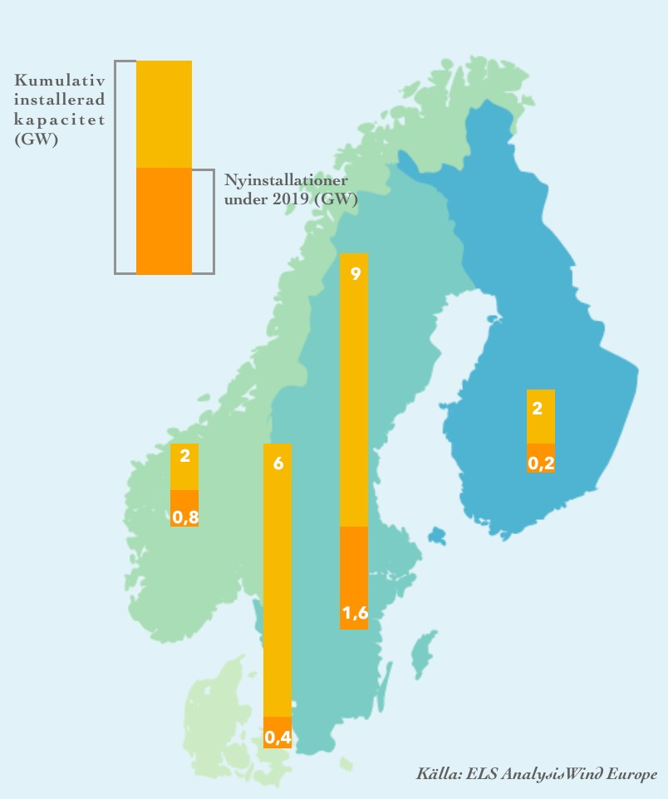

**Figur 3.1.1: Vindkrafts-**

**utbyggnad Norden 2019**

* + 1. As offer of wind power increased and the electricity certificate system's quota obligation did not keep up, the effect of the certificates and wind growth were however weakened reached one plateau during the years 2015-2017. The system underwent a revision and reached during 2018-2019 again certain effect, with good help from weather conditions around summer and the autumn 2018. However, the rise in electricity certificate prices was short-lived and the support system has not been a driving force for investment since before the growth plateau.

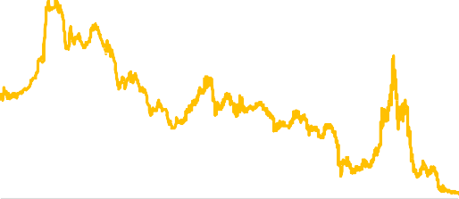

**45%**

**40%**

**35%**

**30%**

**25%**

**20%**

**15%**

**10%**

**5%**

**0%**

**INSTALLERAD VINDKRAFTSKAPACITET OCH ÅRLIG TILLVÄXTTAKT**

**(2020-2023 PROGN.)**

**ELCERTIFIKATSPRISET**

**18000**

**16000**

**14000**

**12000**

**10000**

**8000**

**6000**

**4000**

**2000**

**0**

**450**

**400**

**350**

**300**

**250**

**200**

**150**

**100**

**50**

**0**

Procentuell tillväxt

Installer ad vindkraftskapacitet (MW)

Källa: Svensk Vindenergi

Källa: ELS Analysis, Refinitiv

**Figur 3.1.2 Installerad vindkraft & tillväxt Figur 3.1.3 Elcertifikatpriset**

**SEK**

Investments in new wind power have nevertheless continued, even though the conditions for production growth in general on the Nordic electricity market have only worsened. What made wind power growth possible is to producers during the latest the decade all more often have adopted PPA structures for its price hedging and thus long-term financing, and that there were increasing amounts of capital that sought low risk and low return in the wake of declining investment opportunities in government debt securities. The fact that this capital was able to secure green values and certifications on the purchase has contributed to the attractiveness of the scheme and facilitated project financing. By hedging prices and spreading risk over a long period of time, they have succeeded in attracting a growing number of large electricity buyers, as discussed in chapter 2, and thus found an outlet for the PPA structures.

However, it is important to point out that the relationship between buyer and producer, as well as between investor and producer, is distributed differently in relation to the total. To give an example, a PPA project constitutes a relatively small proportion of a fund manager's total portfolio, while the same PPA investment constitutes the main the part of of the wind project financing, see **figure**

* + 1. The ratio is then multiplied throughout the wind power sector. This is much of the explanation to why the exchange becomes very Big on electricity market, at the same time as the exists continued potential on the financing side.

**Figur 3.1.4: En storhetsmässig och exemplifierande jämförelse mellan den andel PPA utgör i en finansiärs portfölj, kontra den andel samma PPA kan utgöra för ett vindprojekt**

**VINDPROJEKT**

**PPA säkring Andra intäckter**

**FONDFÖRVALTARE**

**Totala inveteringar PPA investering**

## IN one location where large macroeconomic stimulus package rafter on the capital asset, at the same time as societal incentive for Green adjustment pulls capital to a limited range of renewable projects, so it is possible to understand wind growth despite its unfavorable market conditions.

In 2019, Sweden was the fourth largest market for new wind power installations in Europe and Sweden more than doubled the annual growth rate from 11 percent in 2018 to 23 percent in 2019, with almost 1 500 MW new capacity installed, see **figure 3.1.1** Of this one capacity growth is estimated to be only a marginal part from projects with direct financing.

As the analyzes in the above chapter indicate, there are weak signs that the prevailing market situation comes limit the PPA funded the expansion of wind power. Certain major electricity consumers can drag the conclusion to the pressed the price situation on North Pool implies one good possibility of securing low market prices in a few years' time and thus choosing to postpone a PPA procurement. At the same time, however, sees the need for green certificates and a proactive position for climate change not out to reduce and the volatility looks out to increase. Also from one purely

from an economic perspective, there is thus a logic behind securing one's electricity price at current PPA price levels, given the consensus in the market around a rising price in a few years' time, but also continued high volatility, make the profitable with one price hedging, see Episode 2.4. This is particularly clearly for large consumers and industries that have a European exposure to competition, where prices are a lot higher. Is MAN in addition localized in something of Sweden's two southernmost electrical areas so can last summer's electricity shortage and spiking electricity prices in themselves be seen as a harbinger of higher price risks and taken as a reason to apply for a PPA.

However can the wave of financial PPA as entered into during later year be on the way to stop. While the spot price in Sweden is lower than The PPA prices so comes the smoothing of the difference between the spot price and the PPA price too often be unfavorable to the buyer. Given that PPA is now growing stronger in other markets in Europe and the price relationship between market and PPA there looks different, it is likely that purely financial customers with international positions will look away from the Nordic market. However, we do not see that this will have any major effect on the expected wind power growth, as financial contracts no longer represent significant shares of the PPA market in the Nordics, but this is today dominated by physical contracts.

The market development with the low profitability of today's planable electricity production and nuclear power in particular, indicates a continued growth opportunity, while many demand forecasts also pointing up during coming year. ELS Analysis own reference scenario shows on one growth over The EU reference standard as The Energy Agency taken forward. At the same time there are grounds for much more optimistic estimates for future demand growth as exemplified below by of the energy authority scenario high electrification. IN **the figures 3.1.5** and

**3.1.6** two future scenarios are presented from the ELS Analysis report Security of electricity supply - 2045 for Swedish Business (August 2020). These scenarios show that wind power will have to fill a much larger part of the Swedish electricity mix in the long term, not least given current climate goals, see also Episode 3.2, PPA and the climate goals.

**TWh**

200

**MARKNADSBALANS: ENERGIMYNDIGHETENS REFERENSSCENARIO (Referens EU) OCH ELS ANALYSIS EFTERFRÅGEPROGNOS**

150

100

50

0

Vattenkraft Kraftvärme i industrin Vindkraft

Total användning EM referens EU Total användning EM hög elektrifiering

Kärnkraft

Kraftvärme i fjärrvärmesystem Solkraft

Total användning ELS referens

Källa: Energimyndigheten, ELS Analysis

**Figur 3.1.5: Marknadsbalans referensscenario**

The current oversupply, together with wind power's low marginal cost for new production capacity on land (as well as rapidly falling marginal cost for new offshore wind power) raises a very large long-term question mark about the pace of nuclear power's phase-out. Although today's low electricity prices would lead to a stoppage of wind power expansion in the short to medium term term, so exists the very as speaking for to wine power growth would be the first to return and generate new expansion so fast electricity prices recovered one. Other

1990

1992

1994

1996

1998

2000

2002

2004

2006

2008

2010

2012

2014

2016

2018

2020

2022

2024

2026

2028

2030

2032

2034

2036

2038

2040

2042

2044

2046

2048

2050

production type, and probably also new technician for system balancing, would require higher prices to generate new investment.

To and with in the reference scenario as is presented in **figure 3.1.5** , so growing wind power with around 40 TWh between 2020 and 2050. Would the decommissioning of nuclear power happen faster, as in **figure 3.1.6** so is the hole in the supply as wind power comes need fill very major at one earlier phase. With rapidly increasing electrification of society, the need for additional wind power may be as large as around 75 TWh up to and including 2050. At such a stage, the need for system balancing services will Become problematic, which should create investment conditions, but given lead times is the risk then Big to instabilities with negative Result for society already began occur, which in itself opens up risks for sub-optimized short-term solutions and setbacks for climate change.

**TWh**

250

**SCENARIO LÅG KÄRNKRAFT & HÖG VINDKRAFT**

200

150

100

50

0

Vattenkraft Kraftvärme i industrin Vindkraft

Total användning EM referens EU Total användning EM hög elektrifiering

Kärnkraft

Kraftvärme i fjärrvärmesystem Solkraft

Total användning ELS referens Källa: Energimyndigheten,

Svensk Vindenergi, ELS Analysis

**Figur 3.1.6: Marknadsbalans låg kärnkraft & hög vindkraft**

In Europe, the situation looks very different, with above all three distinctive differences compared to the Nordic market:

1990

1992

1994

1996

1998

2000

2002

2004

2006

2008

2010

2012

2014

2016

2018

2020

2022

2024

2026

2028

2030

2032

2034

2036

2038

2040

2042

2044

2046

2048

2050

 Price levels are generally much higher in both spot markets, as well as PPA.

 The relationship between PPA prices and electricity market prices is the reverse compared with the Nordic market since the ridge shift. PPAs are entered into at a discount to spot prices.

 Additionality is defined Often with one wider meaning, as not on same way need to entail specific new construction.

Just like in the north, PPA is growing stronger on the continent as state support systems are phased out and national climate targets are tightened. As the number of interconnections between electrical system growing and The PPA market continues to develop, can one expects standardization and thus also stronger exposure to competition.

# PPA & the climate goals

Sweden's energy and climate goals includes among Other to electricity production 2040 shall be to 100 percent renewable, even if that goal doesn't involve a cut-off date banning nuclear power.

## The is though clearly in the Swedish national the climate strategy to wind power is coming need constitute one considerably major part of the electric mixer.

Then of wind power growth today builds on PPA structures so is Sweden's climate goals also dependence on PPAs and the investments in renewables that they enable. Because Sweden has such a well-developed renewable share of its electric mixer, with wind power in one leading position, so comes not tighter 2030 targets at EU level to significantly affect the Swedish market. However, we may see a significantly greater effect of this in other parts of Europe and it is likely that tighter 2030 targets will generate an increased role for PPA on the continent.

A growing PPA market, as mentioned above, can drive a standardization of contract structures, as well as increased transparency, which can open up revised market rules, where a system perspective is included to a greater extent. This could mean that requirements for system balance services be included as one part in the contracts, but one such development would have to start from a political debate around these electricity system aspects, which has not yet gained momentum. This may take place at national, as well as EU-wide levels. The conclusion is, however, that structures for investments in intermittent renewable electricity production such as PPA are needed in order for these to grow to the extent that climate goals require.

1. SLUTSATSER

This report has concluded that long-term electricity contracts, like PPAs, are not in themselves irrational market phenomenon, without is very logical and suitable tool for risk management from the point of view of producers and buyers. The main benefits for producers are:

 Enable fuse of price risk on long term to the degree to producers can get investments. Can through physical agreements guarantee customer delivery security through balance agent.

 Big ones electrical and energy company can on this way secure one higher share renewable in its total elmix and thereby reduce its climate footprint.

For buyer of long-term contract according to PPA model, connected to mainly wind power, is the main advantages that:

 Secure deliveries and prices for a longer period.

 Capitalize one considerable greens host within CSR, financing, and to benefit for the company's regulatory compliance in the climate area.

Given this, there is both an economic and climate-based logic behind why we have seen such strong growth in PPA linked to wind power expansion in the Nordics and may continue to see it. However, the report has problematized the impact of the PPA structure on the market in its own right overall and thus system stability. It becomes clear that the PPA has a very large impact on the spot market at Nord Pool, but that the spot market does not influence the PPA back. Given that the price is a bilaterally negotiated fixed price and has no price indexation linked to the spot market, there is no direct link between the price development on the Nord Pool spot and the PPA.

In the past, when PPAs linked to wind power were less common, the contract structure as such played less of a role. Now that we have witnessed a development where PPA has taken on an increasingly large role and come to drive the electricity market to a greater degree, certain reforms may be necessary. To broaden the perspective, a comparison with the gas market, which has undergone a similar development, can be fruitful. An essential difference, however, is that the price for long-term contracts on the gas market has always had elements of a fixed share, as well as a variable one that was indexed to some market price. This has led to spot market price signals reaching not only the producer, but also the buyer, creating an opportunity for demand response. To sequence of to the gas market in Europe grew one major and more integrated, so was reformed the mobile one the part in the contract to to indexed against gas trading hubs instead for as earlier crude oil or oil product prices. This is with the aim that market signals from the spot trade in gas would influence buyers and sellers in bilateral long-term contracts.

Unlike from long-term contract on the gas market so exists today No movable variable in PPA which is connected to the development on the electricity market. This make, as the report recurrent described, that the part of the bid side that has hedged itself through the PPA does not react quickly enough to the market signals that the liquid Nord Pool trade sends. Nor does the buyer sense the market signals through his PPA. Both buyers and producers are to some extent exposed to market signals by its remaining sale respective purchase of electricity, so PPA becomes rather, a way to minimize exposure to the market signal. This thus results in the fact that what drives the current oversupply is also secured through it.

From a systemic perspective, this is problematic, as the intermittent part of the supply grows under PPA protection from the low prices that the oversupply generates, while planable production, or system services as would be able to balance the weather dependent the production, not have some investment conditions.

To remedy this constitutes though one difficult challenge. Would MAN change PPA like the structure which can be found on the gas market, through an indexation to the relevant market price, the price signal would also hit the part of supply and demand that currently drives growth. At the same time, however, there would be a risk of dampening the growth increase in the wind power supply that is today so vital for climate change. However, producers and buyers would still have a certain amount of price hedging, but in higher degree be exposed for price signals. Today's investor and lenders would have difficult to accept increased risk levels granted existing arrangement. Oh Other page so is the one naturally step for one market segment as wind power, as matured in on one market, that full and completely take one system integrated responsibility. One responsibility as is imposed all actors on the electricity market, from consumers to lenders and financiers.

Today, there are not many market rules around this type of contract. In other markets, among Other the European gas market, so have Extensive regulations over time developed, not least at EU level. Examples of such rules that in the medium to long term may have some bearing on a renewable electricity market with a high intermittent share are:

 Requirement on regular renegotiation possibilities in long-term contract based on market developments.

 Requirement on how Big share as need be movable (indexed) in price formula. The length of the agreement is limited.

 Limits on the size of individual contracts in relation to the market, or price range, to avoid distortions and market dominance.

Although the supply and price risk today seems secured for both the consumer and the buyer, the perspective needs to be lifted in the long term to what will happen to the planable capacity that now delivers when weather-dependent alternatives do not produce. This given that the price levels is so unfavorable for continued production, or growth in system balance services. Here have market participants one chance to be proactive according to above, but the resting also one large responsibility on central governmental actors to design market rules as ensures system balance on long term.